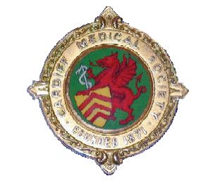

Cardiff Medical Society
Founded 1870

Award of the W T Edwards Medal
Wednesday 5th April 2017

Cardiff Medical Society invites applications from Specialist Registrars and Clinical Research Fellows from across Wales to present their research findings. The applicant must have made a significant contribution to the research project being presented. Quantitative and qualitative research submissions are both welcome.

The best six of the submitted abstracts will be selected for presentation at the April meeting of Cardiff Medical Society. Abstracts will be judged on the basis of; General Interest, Scientific Content, Presentation of Data and Importance to the people of Wales (Impact). Successful applicants will be invited to make an oral presentation to this multidisciplinary meeting which is held at 7.30pm at Dental Lecture Theatre, University Hospital of Wales on Wednesday 5th April 2017.

The presentations will be for 9 minutes with 1 minute for discussion. At the end of the evening selected members of the audience will assess the quality of the presentations and the winner will be awarded £250.

Please e-mail a copy of your abstract(s), including your daytime telephone number and e-mail address to:

Dr Alan Stone, Cardiff University School of Medicine, Centre for Medical Education,
2nd Floor, Neuadd Meirionydd, Heath Park, Cardiff, CF14 4YS
Tel; +44(0)29 20687 173
Email; stoneam@cf.ac.uk

Please note that the closing date for receipt of the abstract is Tuesday 28th February 2017. If you wish further details and advice on the suitability of your material, please contact Dr Stone at the above address.

